**Gross and Net Basis**

Transactions in futures are usually either outright (i.e., buying or selling futures alone) or against bond or forward bond positions in the form of *basis trades*. Basis trades take a view on the cheapness or richness of the futures contract relative to the prices of the bonds in the delivery basket. These trades are important to arbitrageurs who profit from these trades but, from a market perspective, the activity of these arbitrageurs keeps the price of a futures contract near its fair value relative to cash bonds. This section defines basis trades, defines the terms gross and net basis, and then relates the profit and loss (P&L) from basis trades to changes in the net basis.

Before delving into details, it is useful to make the following point about hedging bonds with futures. By equation (14.4), the change in the price of the futures contract at expiration is the change in the price of the CTD divided by its conversion factor. Therefore, the change in the price of *cfCTD* contracts equals the change in the price of the bond or, equivalently, for a fixed CTD, a long position in a contract-sized face amount of the bond is hedged by selling not one contract but *cfCTD* contracts. With this in mind, basis trades are as defined in [Table 14.4](https://www.inkling.com/read/fixed-income-securities-tuckman-serrat-1st/chapter-14/table-14-4).4 Note that buying or selling the basis as described here involves no cash outlay: repo finances the purchase of a bond or invests the proceeds of its sale, and the forward and futures trades, by definition, require no cash.5

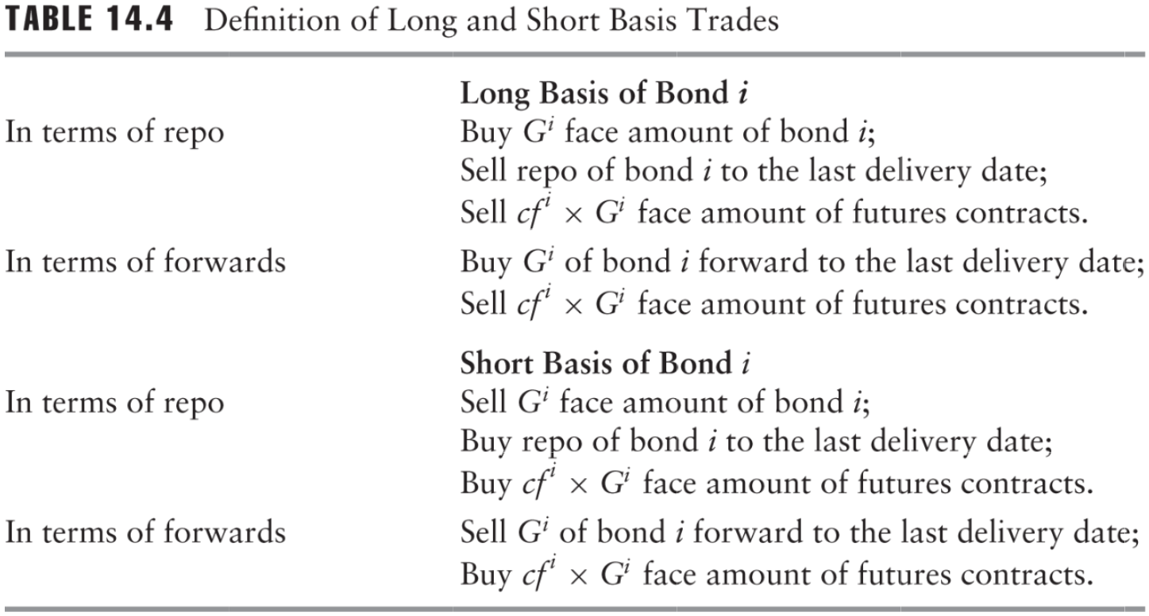

Table 14.4 Definition of Long and Short Basis Trades

Let  be the spot price of bond *i* at time *t*, (*T*) be its forward price to the last delivery date *T* at time *t*, and let *Ft* be the futures price at time *t*. Then the *gross basis* and *net basis* of bond *i* at time *t*, *GBit* and , respectively, *NBit* are defined as

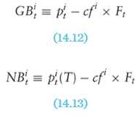

As discussed in [Chapter 13](https://www.inkling.com/read/fixed-income-securities-tuckman-serrat-1st/chapter-13/chapter-13-introduction), the forward drop is synonymous with cash carry or, more simply, carry. Generalizing the notation of equation (13.7) for any deliverable bond, let the carry of bond *i* to the last delivery date *T* be *κi* (*T*). Then

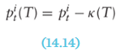

and the definition of net basis in (14.13) can be rewritten as

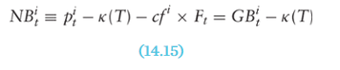

The right-hand side of (14.15) explains the terminology of net basis: it is the gross basis net of carry.

As pointed out in [Chapter 13](https://www.inkling.com/read/fixed-income-securities-tuckman-serrat-1st/chapter-13/chapter-13-introduction), the forward price equals the spot price at delivery, or, equivalently, carry equals zero. This has two implications for the basis quantities at delivery. First, from (14.15), gross basis equals net basis. Second, from (14.1), both measures also equal the cost of delivery.

[Table 14.5](https://www.inkling.com/read/fixed-income-securities-tuckman-serrat-1st/chapter-14/table-14-5) calculates the gross and net basis for all of the bonds in the TYU0 basket as of May 28, 2010. Note that the spot price, carry, gross basis, and net basis are, by common practice, quoted in ticks or 32nds. As an example, consider the 4 ½s of May 15, 2017. According to (14.12), the gross basis is  which equals about 1.379 or 1.379 × 32 = 44.1 ticks. The forward price is calculated along the lines described in [Chapter 13](https://www.inkling.com/read/fixed-income-securities-tuckman-serrat-1st/chapter-13/chapter-13-introduction). By (14.14), carry equals , which is 1.367 or 43.7 ticks. And finally, by (14.15) the net basis is 44.1 − 43.7 or .4 ticks.

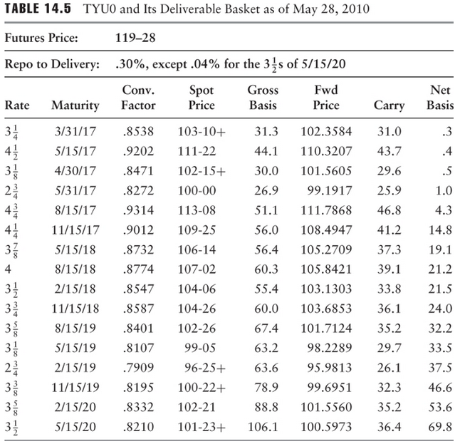

Table 14.5 TYU0 and Its Deliverable Basket as of May 28, 2010

[Chapter 13](https://www.inkling.com/read/fixed-income-securities-tuckman-serrat-1st/chapter-13/chapter-13-introduction) showed that the P&L of a futures position can be considered as realized at delivery, like a forward position, after adjusting the futures position for the tail. For ease of exposition, it is now assumed that all basis positions are properly tailed so that the text can treat a futures position as if its profit were realized at expiration. In other words, in the background of the discussion is an unmentioned tail adjustment. The case study at the end of the chapter explicitly describes this adjustment.

Given the tail adjustment, the P&L on the delivery date from a long basis trade in bond *i* initiated at time *t* and taken off at time *s* is the profit of the long forward position in bond *i* to the delivery date *T* minus the profit of the long futures position. Mathematically, this P&L is



And using the definition of net basis in (14.13), this P&L becomes

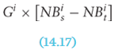

In words, expression (14.17) says that the delivery-date P&L from a long basis position in a bond equals the size of the bond position times the change in that bond’s net basis.

Before concluding this section, it is noted that net basis is far more useful than gross basis in analyzing basis trades. However, because it is particularly easy to observe, gross basis is very commonly used in practice, especially to quote bond prices relative to futures prices. In fact, traders buy and sell packages of a bond and its conversion factor-weighted number of futures contracts at that bond’s quoted gross basis.